A Comprehensive System for Automatic License Plate Detection and Recognition

Khushi Gupta⋆⋆, Sarah Handu, and Vipin Deval

KIET Group of Institutions, Delhi NCR, Ghaziabad - 201206 [khushi.1923cs1125@kiet.edu,](mailto:khushi.1923cs1125@kiet.edu) [sarah.1923cs1027@kiet.edu,](mailto:sarah.1923cs1027@kiet.edu) [vipin.deval@kiet.edu](mailto:vipin.deval@kiet.edu)

**Abstract.** Automatic License Plate Recognition (ALPR), is a comput- erized system that uses optical character recognition (OCR) to auto- matically read license plate information. ANPR systems can be used in a variety of applications such as traffic management, toll collection, and law enforcement.

This research paper explores the advancements in Automatic License Plate Recognition (ALPR) systems, which utilize optical character recog- nition (OCR) technology to automatically extract license plate informa- tion. ALPR finds applications in various domains including traffic man- agement, toll collection, and law enforcement.

The paper highlights the primary advantage of ALPR systems, em- phasizing their exceptional speed and accuracy. Notably, the proposed method demonstrates an increase in accuracy from 82.73 percent (in the YOLO system) to 86.53 percent, showcasing the continual improvement in ALPR technology. ALPR systems excel in efficiently reading license plates at high speeds, enabling the processing of large vehicle volumes. The enhanced accuracy greatly reduces errors, which commonly occur with manual systems or under unfavorable weather conditions.

The research paper outlines a comprehensive five-step procedure for ALPR: vehicle image capture, preprocessing, number plate extraction, character segmentation, and character recognition. To accomplish this, the paper introduces the utilization of advanced techniques such as Gen- erative Adversarial Networks (GANs), OpenCV, and Optical Character Recognition. The inspection camera placement in strategic locations on the vehicle enables efficient identification of the number plate.

Moreover, the study highlights the potential for integrating ANPR sys- tems with complementary technologies like cameras, sensors, and databases. This integration enhances the tracking and identification of vehicles, fur- ther expanding the capabilities of ANPR systems.

In conclusion, this research underscores the significant advantages of ANPR technology, including its remarkable speed, accuracy, and seam- less integration with other technologies. The findings presented in this paper contribute to the ongoing development of ALPR systems, foster- ing their broader adoption in various domains where rapid and reliable license plate recognition is crucial.

⋆⋆ Corresponding author

**Keywords:** License plate, Preprocessing, Generative Adversarial Net- work, Optical Character Recognition

# Introduction

Automatic number plate recognition (ANPR) is a technology that enables the automatic identification and reading of vehicle license plates. ANPR technology is widely used in various fields such as law enforcement, parking management, and toll collection. The technology uses cameras to capture images of license plates, and OCR (optical character recognition) algorithms to extract and rec- ognize the characters on the plate. The system then translates the characters into text, making it possible to identify and track vehicles accurately. One of the primary challenges in ANPR technology is the ability of the system to recognize license plates under different environmental conditions. ANPR systems must be robust enough to recognize license plates under different lighting and weather conditions and at different times of the day. For example, it can be challenging to recognize license plates at night or in low-light conditions [2].

The use of ANPR technology has been on the rise in recent years, driven by the growing demand for intelligent transportation systems and smart city solu- tions. ANPR technology has the ability to automate vehicle tracking and iden- tification, which can significantly improve traffic management, enhance public safety, and facilitate the implementation of sustainable transportation policies. ANPR systems consist of four main components: the image acquisition system, the image processing system, the OCR algorithm, and the database manage- ment system. The image acquisition system captures images of license plates using cameras. The image processing system processes the captured images and removes noise and other artifacts. The OCR algorithm then extracts the charac- ters from the license plate image, and the database management system stores and manages the extracted data [1].

The OCR algorithm is a critical component of ANPR technology, and its accuracy is essential to avoid misidentifying license plates and ensure the cor- rect identification of vehicles. Several factors can affect the accuracy of OCR algorithms, including the quality of the image captured, the lighting conditions, the angle of the camera, and the font used on the license plate. Therefore, the design of the OCR algorithm must consider these factors to ensure the highest possible accuracy. Accuracy performance across different data sets has increased from 82.73 percent in YOLO and 84.83 in Faster R-CNN algorithms to becoming

86.53 percent in Generative Adversarial Network used in our model [6].

The introduction of OCR technology in the 1990s led to the development of automated ANPR systems, which significantly improved the accuracy and efficiency of license plate recognition. The use of OCR algorithms enabled au- tomated recognition of license plates, eliminating the need for manual charac- ter recognition [2]. The advancement of Automatic Number Plate Recognition (ANPR) technology has been greatly influenced by the progress made in deep learning techniques, specifically convolutional neural networks (CNNs) and re-

current neural networks (RNNs). These cutting-edge methodologies have played a significant role in driving the recent improvements in ANPR technology. CNNs and RNNs have been instrumental in enhancing the accuracy and efficiency of ANPR systems by enabling robust feature extraction and sequence modeling, respectively. The utilization of these deep learning techniques has revolutionized the field of ANPR and paved the way for more accurate and reliable license plate recognition [4]. These techniques have shown promising results in improving the accuracy of ANPR systems and reducing errors caused by different environmen- tal conditions. ANPR technology has practical applications in parking manage- ment and toll collection. For example, ANPR systems can be used to automate parking ticket issuance and payment, eliminating the need for physical ticketing and reducing the workload of parking attendants. The use of ANPR technology in toll collection has also been on the rise, with many toll collection systems adopting ANPR technology to automate the system.

Our motivation to write this paper stems from the fact that is an increasingly popular technology used in various settings, but it faces technical and privacy challenges. Research in this area can help to improve the accuracy, speed, and re- liability of ANPR systems, while also addressing privacy concerns and improving real-world applications such as identifying stolen vehicles and enforcing traffic laws.

# Literature Survey

OCR (Optical Character Recognition) technology has been widely used to rec- ognize text and numbers from scanned documents, images, and videos. In license plate recognition, OCR technology plays a crucial role in extracting vehicle reg- istration numbers. The significance of OCR-based number recognition in various applications such as traffic control, security, and surveillance has led to substan- tial research efforts in recent years [14]. In this literature survey, we provide a review of some noteworthy research papers in this domain, highlighting their contributions and approaches.

One significant study titled ”Automatic License Plate Recognition using Deep Convolutional Neural Networks” by R. Tawari, P. Krishna, and S. Chan- dra (2016) focuses on employing deep learning techniques to tackle license plate recognition challenges. The authors propose a deep learning approach utilizing Convolutional Neural Networks (CNNs) for accurate and efficient license plate recognition. They introduce a CNN architecture that can be trained on large datasets of license plate images, demonstrating promising results [14].

Another notable contribution is the research paper by Kakani et al. (year). They present an innovative methodology to enhance OCR-based license plate recognition, particularly in challenging scenarios where the license plate may be partially obstructed or the image is captured at an angle. The authors propose novel techniques to address these difficulties and achieve more accurate and reliable license plate recognition results. Their work offers valuable insights into

improving the performance of OCR-based license plate recognition systems in real-world scenarios [5].

Additionally, a study by Gondhalekar et al. provides a comprehensive com- parison of several state-of-the-art license plate recognition algorithms, including traditional OCR-based methods and deep learning-based methods. The authors evaluate the performance of these algorithms on benchmark datasets and discuss the advantages and disadvantages of each approach. This comparative analysis aids in understanding the strengths and limitations of various techniques in li- cense plate recognition [7].

Another research paper by H. Jain, A. Singh, and P. Jain (2020) titled ”Li- cense Plate Recognition using Deep Learning and Image Processing Techniques” presents a license plate recognition system that combines deep learning and im- age processing techniques. The authors propose a pipeline consisting of image segmentation, character segmentation, and character recognition modules. They evaluate the performance of their system on real datasets, providing insights into the effectiveness of their approach [10].

The literature review demonstrates the sustained interest in developing OCR- based license plate recognition systems with a specific focus on enhancing ac- curacy and reliability in real-world scenarios. These research contributions con- tribute valuable insights, proposing innovative techniques, and comparing dif- ferent approaches. Future work in this field can build upon these studies to further advance the capabilities of OCR-based license plate recognition systems, enabling their wide application in diverse domains.

# Proposed Method

The proposed method introduces a well-structured architecture that consists of several distinct modules to ensure efficient and accurate performance. These modules include Image Capture, Preprocessing, Number Plate Extraction, and Character Segmentation and Character Recognition. The Image Capture module serves as the initial stage, responsible for capturing images for further process- ing. The Preprocessing module then handles the task of preparing the captured images by applying necessary filters and enhancements to optimize their qual- ity and reduce noise. Next, the Number Plate Extraction module focuses on precisely extracting the number plate regions from the preprocessed images us- ing advanced techniques and algorithms. Lastly, the Character Segmentation and Character Recognition module plays a crucial role in segmenting individual characters from the extracted number plate and employing powerful recognition algorithms to accurately identify and interpret these characters. By breaking down the proposed architecture into these modules, the method aims to stream- line the license plate recognition process and achieve superior results. A brief study of all these is covered below.

## Image Capture

The primary step in ANPR is the image capturing of the license plate. Images that are ideal for ANPR use should be able to be captured by the camera. This is essential to the system’s overall effectiveness. It might be challenging to get a clear picture of a license plate because of poor lighting, a lot of other plates, and the area that the plate takes up in the picture. The type of integrated camera has an impact on how well the ANPR system performs while controlling hundreds of parking spaces, reducing traffic jams, or quickly recognizing traffic infractions. Due to the need to account for ambient light, choosing the appropriate camera for this application requires careful consideration of crucial elements including shutter artifacts, exposure periods, and dynamic range [5]. Mostly HDR camera is recommended. The difference between a normal camera and an HDR camera can be seen in figure 1 and figure 2. Next, the discussion shifts towards the place- ment of the gadgets. In comparison to software triggers that can be configured remotely from a control center, adjusting traffic cameras to capture vehicles ac- curately requires physical intervention at the location. This involves tilting the cameras on-site to ensure optimal positioning. Apart from the ball joint situated on the camera console, the ANPR imaging process necessitates securely bolt- ing the camera console base onto the gantry. These physical adjustments are crucial for achieving precise and reliable Automatic Number Plate Recognition (ANPR) results [17]. This ensures that the gadget will remain in place even in difficult circumstances. When fixing the equipment to its permanent places, in- stallation workers must additionally tilt the camera at the ideal 20° to 30° angle. An example of which can be seen in figure 3.

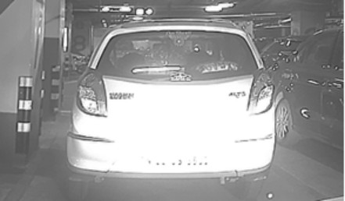

**Fig. 1.** Image captured by normal camera

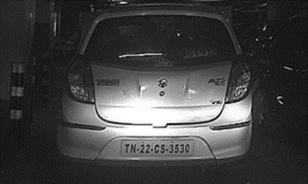

**Fig. 2.** Image captured by HDR camera

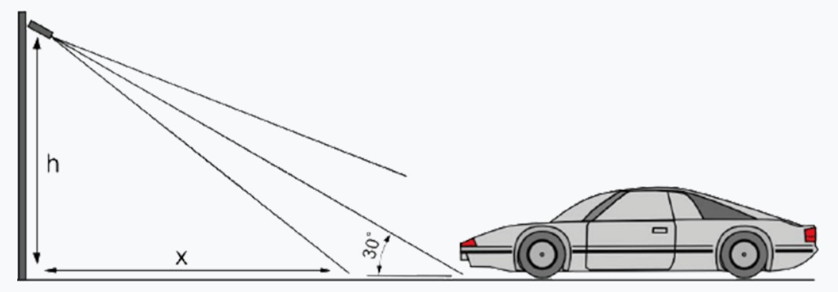

**Fig. 3.** Calculated angle for acurate image capture

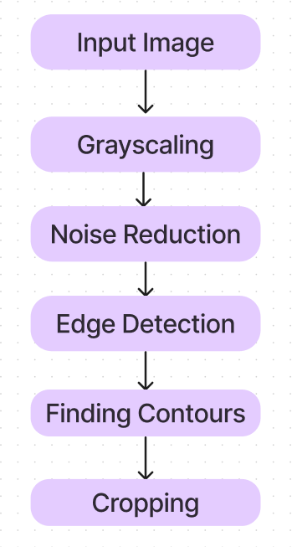

**Fig. 4.** Flow chart for preprocessing of image

## Preprocessing

After the successful capturing of the image, the next step is of pre-processing the image. The main aim of preprocessing is to enhance the processing speed of the algorithm. It is helpful in improving the contrast of the captured im- age and reducing noise. For preprocessing, the algorithm used is the OpenCV library. OpenCV is an extensive open-source library that encompasses a wide range of functionalities related to computer vision, machine learning, and image processing. With its vast collection of tools and algorithms, OpenCV has be- come a pivotal component in various applications requiring real-time operation, which holds paramount significance in today’s systems. Its ability to handle tasks efficiently in real-time, such as object detection, facial recognition, and video processing, has made it indispensable in numerous fields like surveillance,

**Fig. 5.** Greyed Image

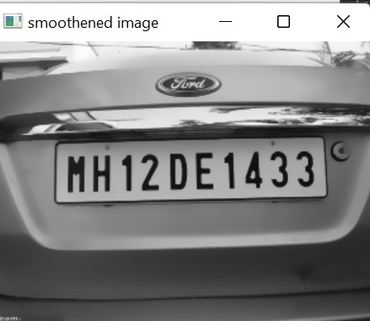

**Fig. 6.** Smoothed Image

robotics, augmented reality, and autonomous vehicles. By providing an accessible and comprehensive set of tools, OpenCV empowers developers and researchers to implement advanced computer vision techniques and build robust and high- performance systems that cater to the demands of modern technology. It provides all the facilities from reading an image to contouring. The original image cap- tured is in RGB format. The first step is to convert it to Greyscale. Greyscaling is done to detect edges easily and reduce model complexity.Many algorithms are customized to work only on grayscale images [16]. OpenCV provides various methods for greyscaling. Here the method used is cv2.COLOR BGR2GRAY. After the greyscaling is done, noise removal needs to be performed. Denoising an image refers to the process of reconstruction of a signal from noisy images. Denoising is done to remove unwanted noise from the image to analyze it in a better form. It refers to one of the major pre-processing steps. In our algorithm noise detection can be performed using a bilateral filter. Then in the next step detection of edges on the smoothed image is performed using a canny edge detec- tion algorithm which uses Gaussian smoothing to remove edges. The next step is to find contours from the processed image in the previous step. Contours are defined as the line joining all the points along the boundary of an image that are having the same intensity. We have used findContour() function that helps in extracting the contours from the image. Now comes the process of sorting the identified contours which are done using the sorted function in OpenCV. A brief representation of the steps involved in preprocessing is: 4. Outputs after

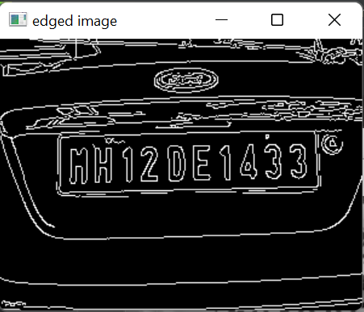

**Fig. 7.** Edged Image

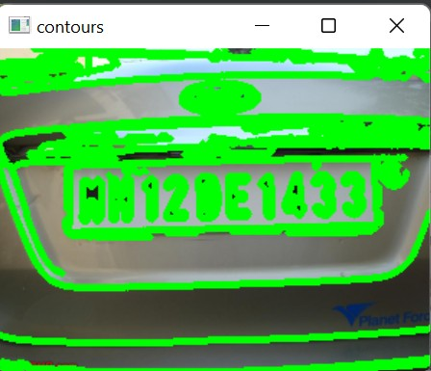

**Fig. 8.** Image after performing Contours

each process can be seen in figure 12,figure 5, figure 6, figure 7, figure 8, figure 9, figure 10, figure 11

## Number Plate Extraction

In this section, we propose in our novel generative framework the use of Genera- tive Adversarial Networks (GANs) to generate features that provide robustness for license plate detection on preprocessed images. [1] GANs are unsupervised deep learning techniques. Usually, it is implemented using two neural networks: Generator and Discriminator [3]. The main goal of the generator is to maximize the loss of the discriminator. Figure 13

The Discriminator loss is

*L*D = *−E*xr [log (*D* (*x*r*, x*f ))] *− E*xf [log (1 *− D* (*x*f *, x*r))] (1) The Adversarial loss for the generator is as follows

*L*G = *−E*xr [log (1 *− D* (*x*r*, x*f ))] *− E*xf [log (*D* (*x*f *, x*r))] (2)

*x*r and *x*f denotes real image and fake image, respectively, while *E*xr and *E*xf represent the operation of taking an average of all real and fake images, respectively.

**Fig. 9.** Top 30 contours on Image

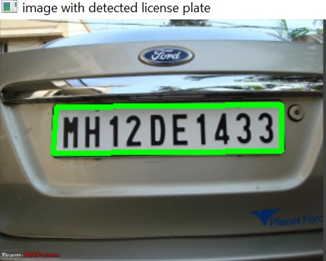

**Fig. 10.** Image with detected Licence Plate

Summing up, we have

*min*G*max*D*V* (*D, G*) = *E*x p*d*ata(x) [log (*D* (*x*))] +

*E*z px*z* (z) [log (1 *− D* (*G* (*z*)))]

The LR image undergoes a series of convolutional and ReLU layers. It is then passed through the RRDB block to incorporate residual learning for training our adversarial loss function. The discriminator function contributes to generating authentic textures. In the process of the RRDB model, we start with the Low- Resolution image (x) as input. The feature extraction takes place through the convolutional layer, and the resulting features are utilized as input for the RRDB mode. [9].

*F*0 = *K*CNN (*x*) (3)

*F*0 Let’s consider the process involving feature extraction and residual dense blocks in relation to the LR image (x). The feature extracted by the convolutional layer, denoted as F and obtained using the kernel Kcnn, serves as an input. When utilizing n residual dense blocks, the output of the nth RRDB model can be represented as follows.

*F*N = *K*RRDB*n* (*F*rrdb*−*1) (4)

In our model, we incorporated 26 RRDB blocks, each representing the nth RRDB operation, which encompasses the operations of both Convolutional Neu- ral Networks (CNN) and Rectified Linear Units (ReLU) layers. Furthermore, we

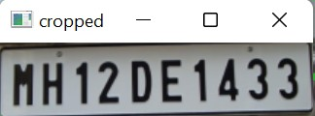

**Fig. 11.** Cropped Image

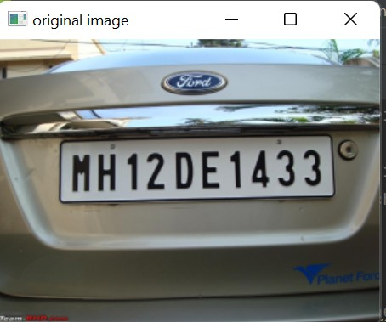

**Fig. 12.** Original Image

employed ReLU as the activation function throughout the model. The dense function of the CNN and RRDB blocks is precisely formulated to ensure opti- mal performance and effective feature extraction. [15]

*F*n,c = *σ* (*W*n,c [*F − n −* 1*, F*n*−*2*, ....., F*n,c*−*1]) (5)

where *σ* denotes the activation function. The Global Residual Learning is

2

Σ

*F*GRL = 6*F*n,c (6)

1

In this context, the output of the first convolutional layer plays a crucial role in capturing essential features and patterns from the input data. By incorporating the global residual learning approach, the network can effectively learn and refine these features throughout the subsequent layers, ultimately leading to improved performance and better representation of the data.

*F*total = *F*GRL + *F*0 (7)

## Character Segmentation and Character Recognition

Characters are further recognized after the identification of license plates. Seg- mentation that is based on recognition is often referred to as implicit segmenta- tion. Segmentation and character recognition are accomplished simultaneously in this process. The system breaks down the image into its component parts. Words that should be characters are divided into segments by the implicit segmentation program, which then sends each segment to a classifier. When segmentation is called again with the feedback that the previous sequence was rejected, the clas- sification results should be appropriate. The system can detect and transform the

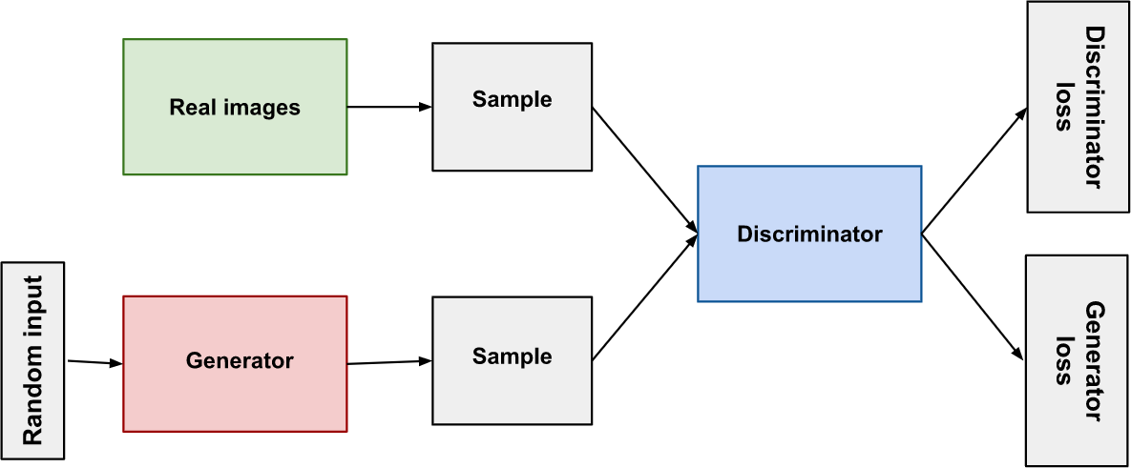

**Fig. 13.** Image Detection through OCR

image into text by using character recognition. Here for character segmentation and Recognition, we use Optical Character Recognition(OCR). Once, the license plate is detected and pre-processed for segmentation and then passed forward through the Character Recognition process to detect alphanumeric characters [8]. fig16

Optical character recognition (OCR) refers to the process of converting text from various sources, including handwritten, printed, or typed text, into machine- readable format. This conversion takes place by analyzing images captured from different mediums, such as photographs of documents, scanned documents, or even scene photos. OCR technology plays a crucial role in automating data entry tasks, digitizing physical documents, and enabling text searchability. By leverag- ing sophisticated algorithms and image processing techniques, OCR systems can accurately extract textual information from images, enabling efficient text anal- ysis and manipulation in various applications. OCR is mainly used in Artificial Intelligence, computer vision, and most important pattern recognition.

# Results and Discussion

ANPR by OCR is a technology that uses optical character recognition (OCR) to automatically identify and read license plates on vehicles. The process involves capturing an image of the license plate with a camera, processing the image to extract the characters on the plate, and then using OCR algorithms to recognize and translate the characters into the text. The technology has many applications, including law enforcement, parking management, and toll collection.

Research in ANPR by OCR typically focuses on improving the accuracy and efficiency of the technology. Common results and discussion topics in this field include:

1. Accuracy: Researchers often evaluate the accuracy of ANPR systems by comparing the recognized license plate numbers to ground truth data. This can involve analyzing the frequency and types of errors made by the OCR algo- rithms, such as misread characters or incorrect formatting. Researchers may

also compare the accuracy of different OCR algorithms or processing techniques to determine which methods are most effective [11].

1. Speed: Another important factor in ANPR research is the speed of the technology. Researchers may evaluate the processing time required to recognize license plate numbers, as well as the speed at which the system can capture and process images of moving vehicles. This can help determine whether the technology is suitable for real-time applications such as toll collection or parking management.
2. Robustness: ANPR systems must be able to accurately recognize license plates in a variety of conditions, including different lighting, weather, and camera angles. Researchers may evaluate the robustness of the technology by testing it under different environmental conditions and analyzing the frequency and types of errors made [12].
3. Dataset creation and augmentation: Researchers also work on creating datasets for the training and evaluation of ANPR systems. This includes cap- turing images of license plates under different conditions and annotating them with ground truth data. In addition, researchers may work on techniques for data augmentation, such as generating synthetic images with different backgrounds or distortions, to improve the robustness of the OCR algorithms [13].
4. Deep learning methods: Recently, deep learning techniques have shown promise in improving the accuracy of ANPR systems. Researchers may investi- gate the the use of convolutional neural networks (CNNs) and recurrent neural networks (RNNs) or other deep learning architectures to ANPR. This may in- clude exploring transfer learning approaches that leverage pre-trained models on large datasets such as ImageNet, or developing novel models that can handle the specific challenges of ANPR [14].

Overall, research in ANPR by OCR is a dynamic and active field that involves a range of technical and practical challenges. By improving the accuracy, speed, and robustness of ANPR systems, researchers can help enable a wide range of applications that depend on automatic license plate recognition.

|  |  |  |  |
| --- | --- | --- | --- |
| Accuracy performance around different datasets | | | |
| Method | Faster R-  CNN | YOLO | GAN(Ours) |
| Small | 73.94% | 80.88% | 79.10% |
| Small + | 68.64% | 78.50% | 72.67% |
| Inclined |  |  |  |
| Medium | 96.94% | 97.62% | 97.64% |
| Medium | 90.19% | 90.89% | 91.18% |
| + In- |  |  |  |
| clined |  |  |  |
| Large | 99.50% | 99.30% | 99.50% |
| Total | 84.83% | 82.73% | 86.53% |

Above table shows the mathematical representation of the improved accuracy using Generative Adversarial Network compared with some other algorithms used in previous researchs like Faster R-CNN and YOLO.

# Conclusion and Future Work

In conclusion, the research presented in this paper underscores the significant advancements in Optical Character Recognition (OCR) technology for number plate recognition. The successful implementation of OCR in license plate recog- nition systems has demonstrated its efficacy in various applications. However, there remains ample scope for future work in this field, as OCR technology continues to evolve and improve.

One area of future exploration lies in the improved handling of variations in number plate formats. Different countries and regions have diverse formats for their license plates, posing a challenge for OCR systems. Future research should focus on developing robust algorithms capable of handling these variations with greater ease and accuracy. This could involve the integration of machine learning techniques and sophisticated pattern recognition algorithms to adapt to different plate formats [18].

Integration with other technologies presents another avenue for future work in OCR-based number plate recognition. By combining OCR technology with license plate databases or Vehicle Information Management Systems, additional functionalities can be achieved. This integration would enable real-time retrieval of vehicle-related information, facilitating enhanced law enforcement, traffic man- agement, and security applications.

Furthermore, the rise of special number plates, such as temporary or special- purpose plates, poses new challenges for OCR technology. Future research should focus on adapting OCR algorithms to effectively recognize these unique plate formats. This may involve collecting specialized datasets, refining existing al- gorithms, and exploring novel techniques such as deep learning architectures specifically tailored for handling such challenges.

In summary, the field of OCR number plate recognition offers substantial opportunities for future advancements. Researchers and developers can continue to refine and enhance OCR technology to meet the changing needs of society. By addressing issues such as plate format variations, integration with other tech- nologies, and adaptation to new challenges, OCR-based number plate recogni- tion systems can further solidify their position as a critical component of modern transportation, surveillance, and security systems. [19].

# References

1. Kukreja, Vinay, Deepak Kumar, and Amandeep Kaur. ”GAN-based synthetic data augmentation for increased CNN performance in Vehicle Number Plate Recog- nition.” 2020 4th international conference on electronics, communication and aerospace technology (ICECA). IEEE, 2020.
2. Kulkarni, A., Munot, M., and Korade, S. S. S. M. N. A SURVEY ON VARIOUS AVAILABLE OBJECT DETECTION MODELS AND APPLICATION IN AUTO- MATIC LICENCE PLATE DETECTION.
3. Beibut, A., Magzhan, K., and Chingiz, K. (2014, October). Effective algorithms and methods for automatic number plate recognition. In 2014 IEEE 8th International

Conference on Application of Information and Communication Technologies (AICT) (pp. 1-4). IEEE.

1. Omar, N., Abdulazeez, A. M., Sengur, A., and Al-Ali, S. G. S. (2020). Fused faster

RCNNs for efficient detection of the license plates. Indonesian Journal of Electrical Engineering and Computer Science, 19(2), 974-982.

1. Kakani, B. V., Gandhi, D., and Jani, S. (2017, July). Improved OCR based auto-

matic vehicle number plate recognition using features trained neural network. In 2017 8th international conference on computing, communication and networking technologies (ICCCNT) (pp. 1-6). IEEE.

1. Zhai, X., Bensaali, F., and Sotudeh, R. (2012, July). OCR-based neural network for

ANPR. In 2012 IEEE International Conference on Imaging Systems and Techniques Proceedings (pp. 393-397). IEEE.

1. Bansal, S., Gupta, M., and Tyagi, A. K. (2020, July). A necessary review on optical

character recognition (OCR) system for vehicular applications. In 2020 Second In- ternational Conference on Inventive Research in Computing Applications (ICIRCA) (pp. 918-922). IEEE.

1. Singh, J., and Bhushan, B. (2019, October). Real time Indian license plate detection

using deep neural networks and optical character recognition using LSTM tesser- act. In 2019 international conference on computing, communication, and intelligent systems (ICCCIS) (pp. 347-352). IEEE.

1. Arora, M., Jain, A., Rustagi, S., and Yadav, T. (2019). Automatic number plate

recognition system using optical character recognition. International Journal of Sci- entific Research in Computer Science, Engineering and Information Technology, 5(2), 986-992.

1. Gondhalekar, D., Chalke, O., Bansal, S., and Banerjee, S. (2021). Vehicle License

Plate Recognition Using Neural Networks. Available at SSRN 3866116.

1. Ahmed, A. A., and Ahmed, S. (2021). A Real-Time Car Towing Management Sys- tem Using ML-Powered Automatic Number Plate Recognition. Algorithms, 14(11), 317.
2. Mufti, N., and Shah, S. A. A. (2021). Automatic number plate Recognition: A

detailed survey of relevant algorithms. Sensors, 21(9), 3028.

1. Weihong, W., and Jiaoyang, T. (2020). Research on license plate recognition al- gorithms based on deep learning in complex environment. IEEE Access, 8, 91661- 91675.
2. Ap, N. P., Vigneshwaran, T., Arappradhan, M. S., and Madhanraj, R. (2020,

July). Automatic Number Plate Detection in Vehicles using Faster R-CNN. In 2020 International Conference on System, Computation, Automation and Networking (ICSCAN) (pp. 1-6). IEEE.

1. Khinchi, M., and Agarwal, C. (2019, February). A review on automatic number

plate recognition technology and methods. In 2019 International Conference on Intelligent Sustainable Systems (ICISS) (pp. 363-366). IEEE.

1. Creswell, Antonia, Tom White, Vincent Dumoulin, Kai Arulkumaran, Biswa Sen-

gupta, and Anil A. Bharath. ”Generative adversarial networks: An overview.” IEEE signal processing magazine 35, no. 1 (2018): 53-65.

1. Zhao, Junbo, Michael Mathieu, and Yann LeCun. ”Energy-based generative ad-

versarial network.” arXiv preprint arXiv:1609.03126 (2016).

1. Wang, Kunfeng, Chao Gou, Yanjie Duan, Yilun Lin, Xinhu Zheng, and Fei-Yue Wang. ”Generative adversarial networks: introduction and outlook.” IEEE/CAA Journal of Automatica Sinica 4, no. 4 (2017): 588-598.
2. Eikvil, L. (1993). Optical character recognition. citeseer. ist. psu. edu/142042. html,

26.

1. Charles, P. K., Harish, V., Swathi, M., and Deepthi, C. H. (2012). A review on the various techniques used for optical character recognition. International Journal of Engineering Research and Applications, 2(1), 659-662.
2. Lima, C. S. (2022). Using a super resolution network and general-purpose optical character recognition for license plate recognition.
3. Kumar, A. D. P., Matta, H., Saka, P., Erusu, P. R., and Koyyalmudi, D. C. Auto- matic Smart Car Parking System Using Iot and Python.
4. Kasaraneni, D. (2020). Autonomous Vehicle Number Plate Recognition Using a YOLO and ESRGAN Framework (Doctoral dissertation, Texas A&M University- Kingsville).
5. Vaˇsek, V. (2018). Automated number plate recognition from low quality video- sequences.
6. Paruchuri, H. (2015). Application of Artificial Neural Network to ANPR: An Overview. ABC Journal of Advanced Research, 4(2), 143-152.
7. Kulkarni, P., Khatri, A., Banga, P., & Shah, K. (2009, April). Automatic number plate recognition (anpr) system for indian conditions. In 2009 19th International Conference Radioelektronika (pp. 111-114). IEEE.